43.77: (a) There are two processes occurring: the creation of 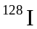 by the neutron irradiation, and they decay of the newly produced . So 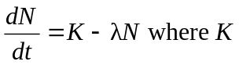 is the rate of production by the neutron irradiation. Then 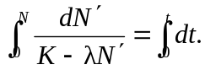
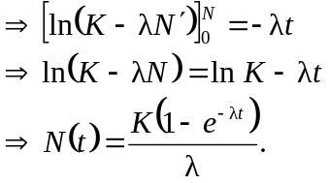
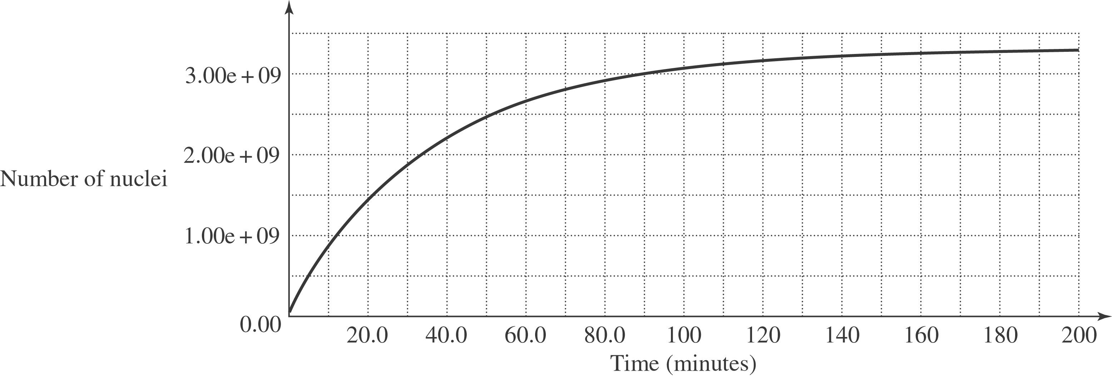

b) The activity of the sample is
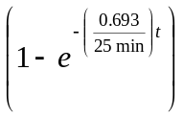. So the activity is 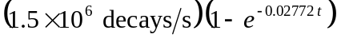, with t in minutes. So the activity 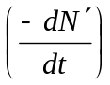 at various times is:
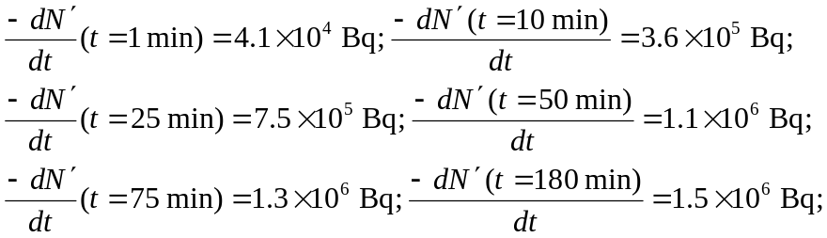
c) 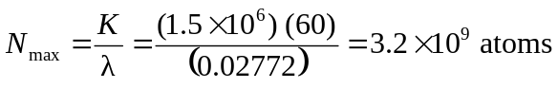.
d) The maximum activity is at saturation, when the rate being produced equals that decaying and so it equals 